MINISTRY OF EDUCATION AND SCIENCE OF THE RUSSIAN FEDERATION
federal state autonomous educational institution of higher education

NATIONAL RESEARCH
TOMSK POLYTECHNICAL UNIVERSITY

School of Information Technology and Robotics
Department of Information Technology
The direction of "Computer Science and Engineering"

Report on the laboratory work on the subject "Professional training in English"
«Protocol analyzing with WireShark and VLC Player»

Completed:
Student group 8VM82 _________________ A.K. Bokijonov

Checked:
Assistant (ICT, ISHITR) _________________ V.V. Loskutov

Тomsk 2019
Working process
The task: using WireShark and VLC Player, analyze media transmission protocols for the Non-Real-Time (download multimedia file) and Real-Time (Internet broadcast reception) options.
Objective: gain practical skills in analyzing multimedia traffic.
The attached information relates to SCMP packet structure.
The Stream Control Transmission Protocol (SCTP) has a simpler basic packet structure than TCP. Each consists of two basic sections:
- The common header, which occupies the first 12 bytes. In the adjacent diagram, this header is highlighted in blue.
- The data chunks, which form the remaining portion of the packet. In the diagram, the first chunk is highlighted in green and the last of N chunks (Chunk N) is highlighted in red. There are several types, including payload data as well as different control messages.
A three-way handshake is a method used in a TCP/IP network to create a connection between a local host/client and server. It is a three-step method that requires both the client and server to exchange SYN and ACK (acknowledgment) packets before actual data communication begins.
A three-way handshake is primarily used to create a TCP socket connection. It works when:
- A client node sends a SYN data packet over an IP network to a server on the same or an external network. The objective of this packet is to ask/infer if the server is open for new connections.
- The target server must have open ports that can accept and initiate new connections. When the server receives the SYN packet from the client node, it responds and returns a confirmation receipt – the ACK packet or SYN/ACK packet.
- The client node receives the SYN/ACK from the server and responds with an ACK packet.
Upon completion of this process, the connection is created and the host and server can communicate.
Wireshark is the world’s foremost and widely-used network protocol analyzer.

Wireshark has a rich feature set which includes the following:
- Deep inspection of hundreds of protocols, with more being added all the time
- Live capture and offline analysis
- Standard three-pane packet browser
- Multi-platform: Runs on Windows, Linux, macOS, Solaris, FreeBSD, NetBSD, and many others
- Captured network data can be browsed via a GUI, or via the TTY-mode TShark utility
- The most powerful display filters in the industry
- Rich VoIP analysis
- Capture files compressed with gzip can be decompressed on the fly
- Live data can be read from Ethernet, IEEE 802.11, PPP/HDLC, ATM, Bluetooth, USB, Token Ring, Frame Relay, FDDI, and others (depending on your platform)
- Decryption support for many protocols, including IPsec, ISAKMP, Kerberos, SNMPv3, SSL/TLS, WEP, and WPA/WPA2
- Coloring rules can be applied to the packet list for quick, intuitive analysis
- Output can be exported to XML, PostScript®, CSV, or plain text

Step 1: Install the WireShark and VLC Player programs. (picture 1 and picture 2).

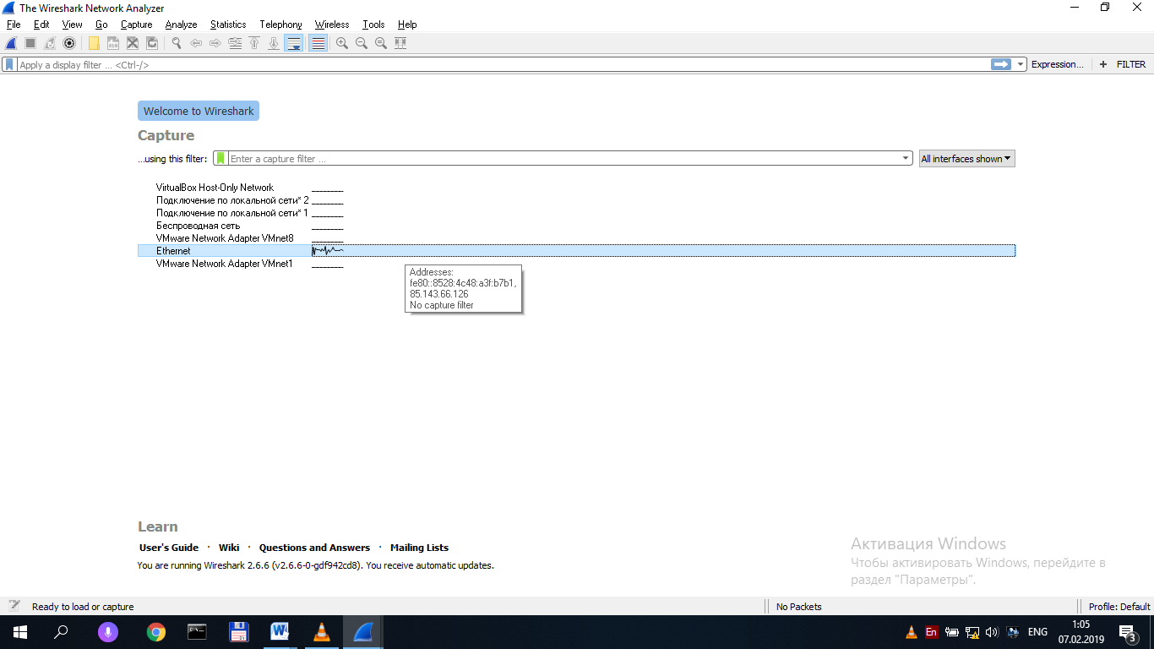
Figure 1 - The Main window of the WireShark.
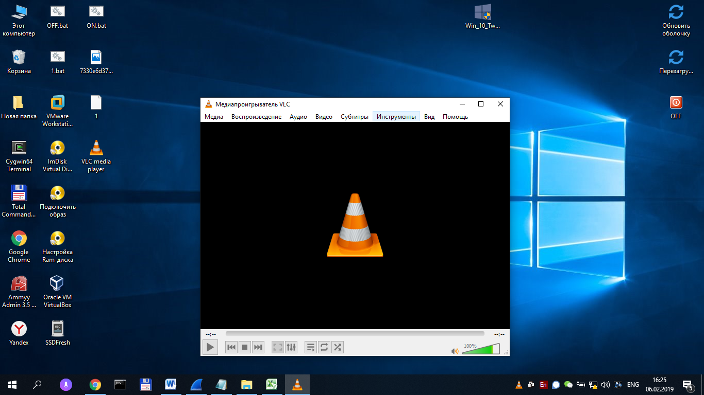
Step 2: Real-Time
You just activate this tool and click “File” and then “Open Network Stream” on top menu.
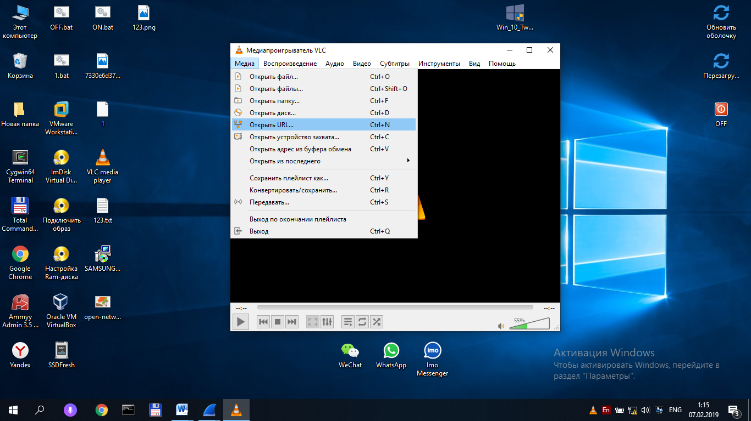
Figure 2 - VLC Player
After that, just copy and paste the URL of a video clip into given field, and then click to confirm it. This will play video directly on VLC (figure 3 and figure 4). 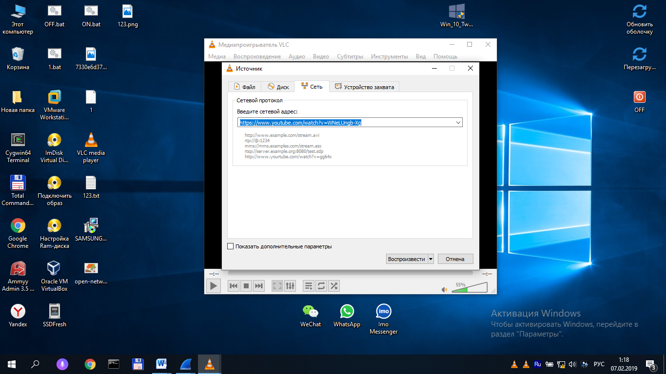

figure 3 and figure 4

After connecting, go to the program WireShark and select “Ethernet”. (figure.5).


Figure 6.
Then we need to know your ip address. Display Run using Windows+R, type CMD and hit OK. Input ipconfig and press Enter. My Ip address = 85.143.66.126(figure 7)

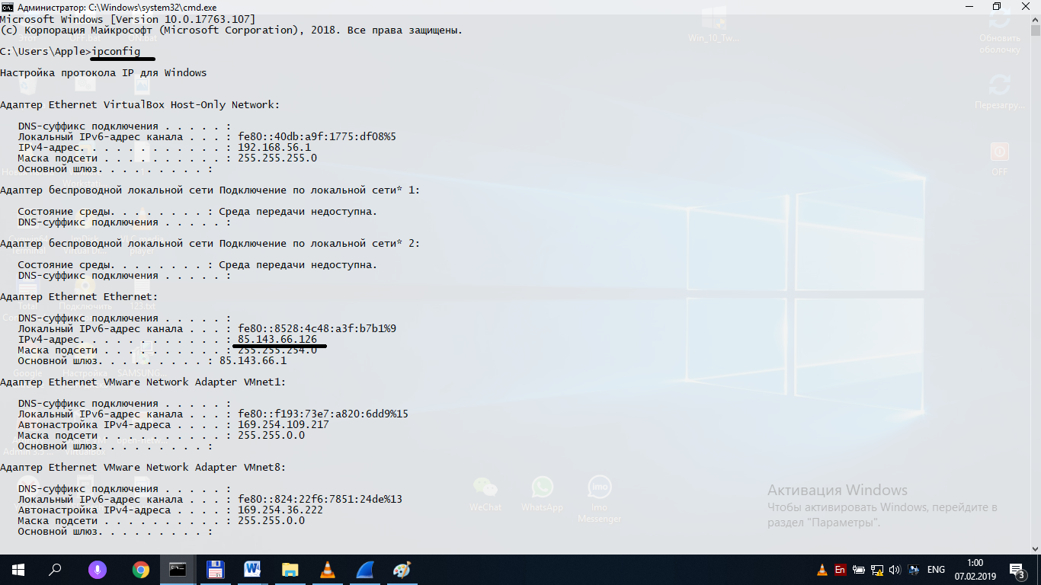 Figure 7

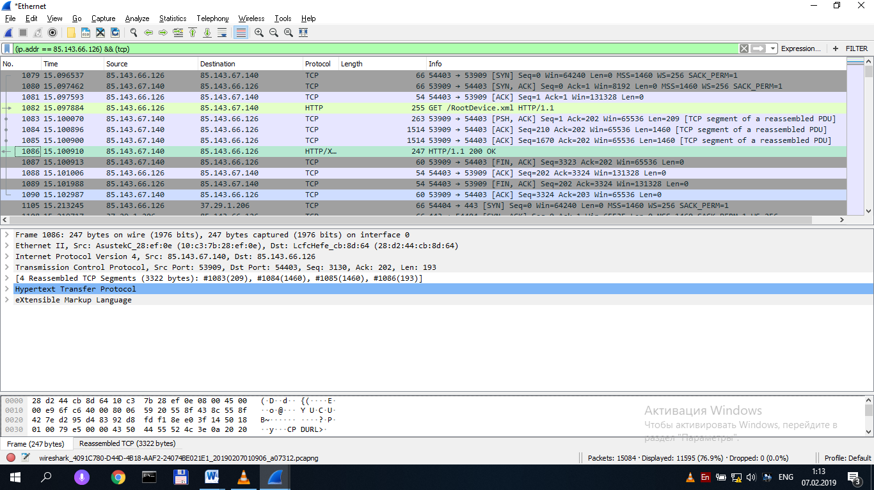
Figure 8. Ethernet network connection with filter TCP

Now the program analyzes incoming and outgoing traffic. We need to type (ip.addr == 85.143.66.126) && (tcp) in toolbar and press ENTER(figure 8).
Find the SYN flag (figure 9).
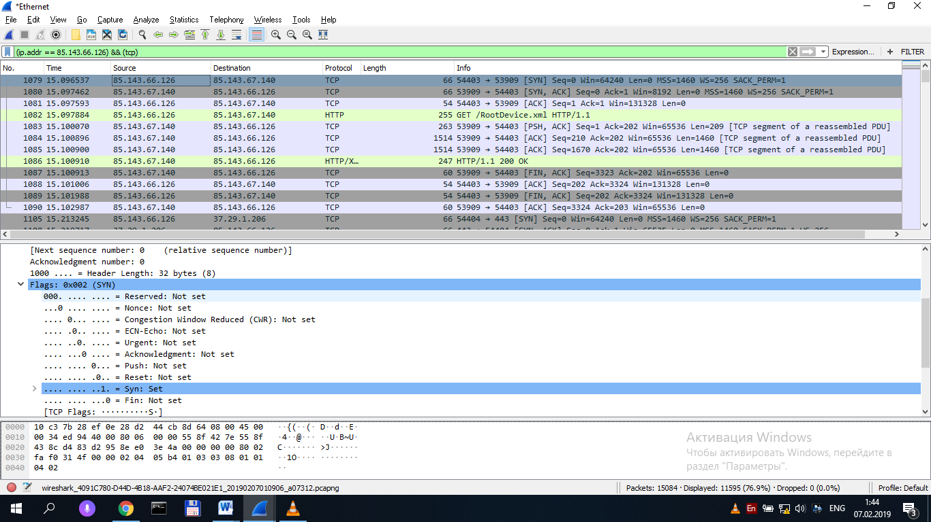
Figure 9. SYN flag
Followed by packets with the SYN flag , ACK (figure 10).
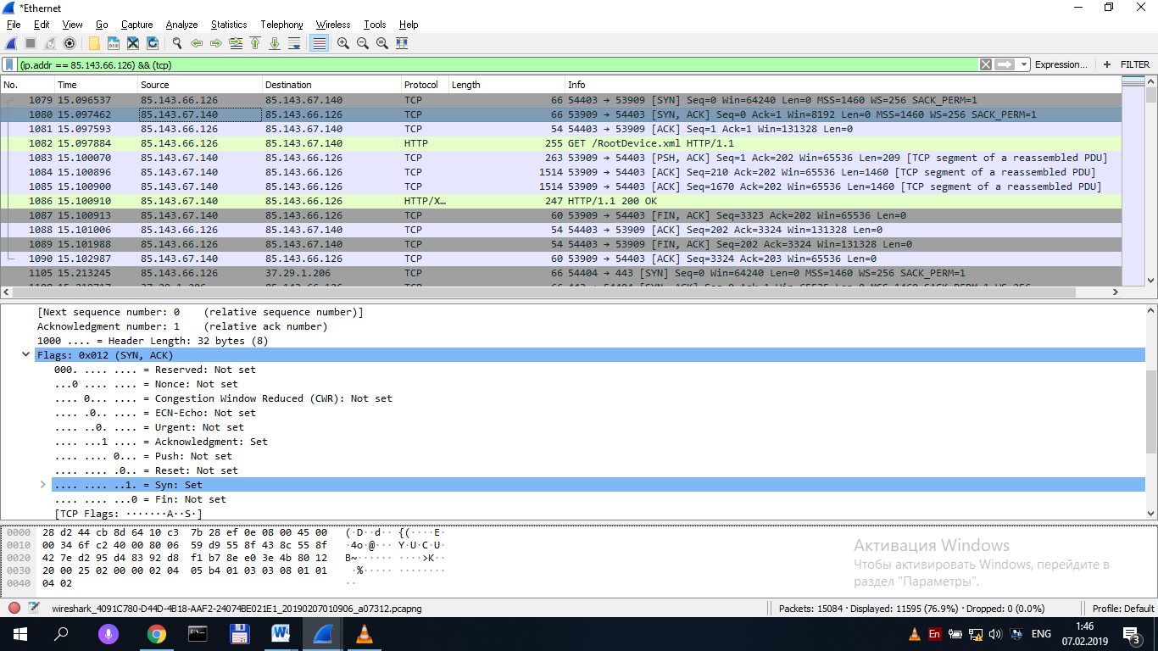 Figure 10. Flag SYN,ACK
Came a package with flag ACK confirmation (Figure 11).
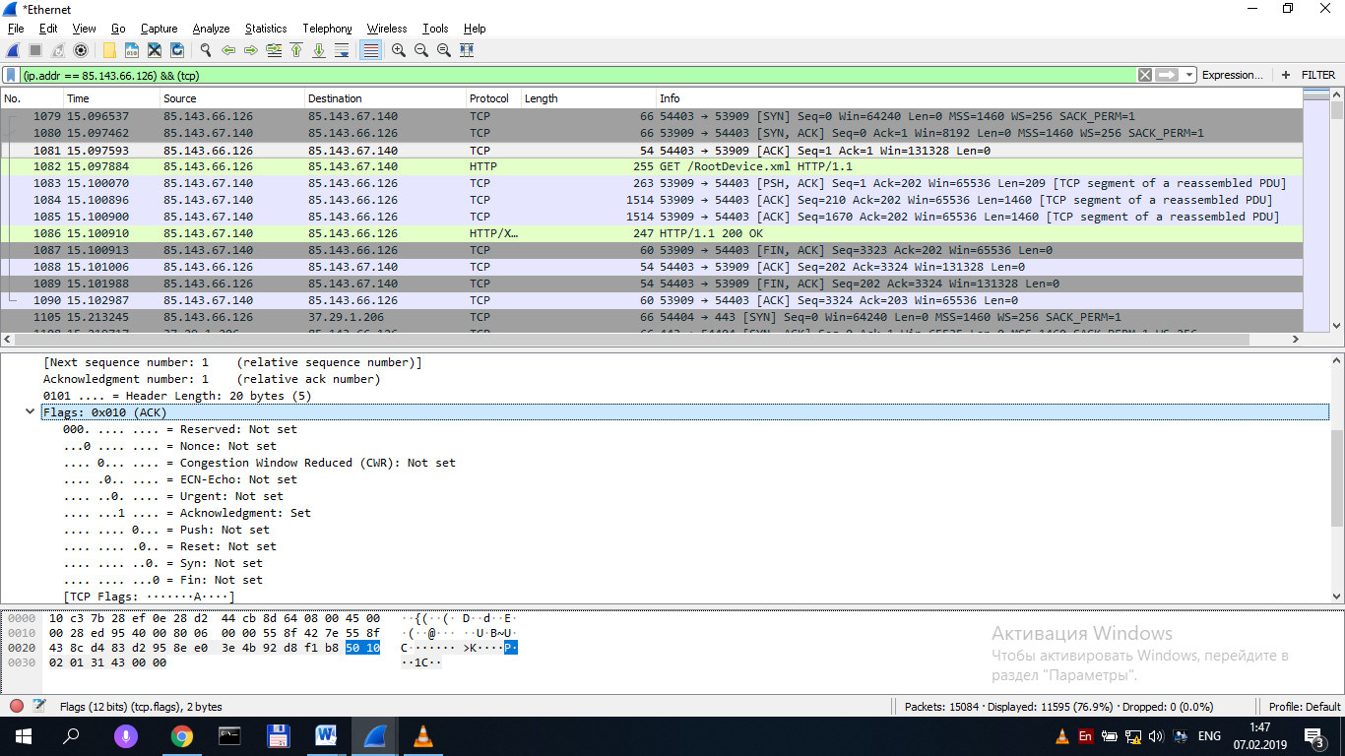
Figure 11. ACK flag
The end of the connection is indicated with a flag FIN , ACK (figure 12).
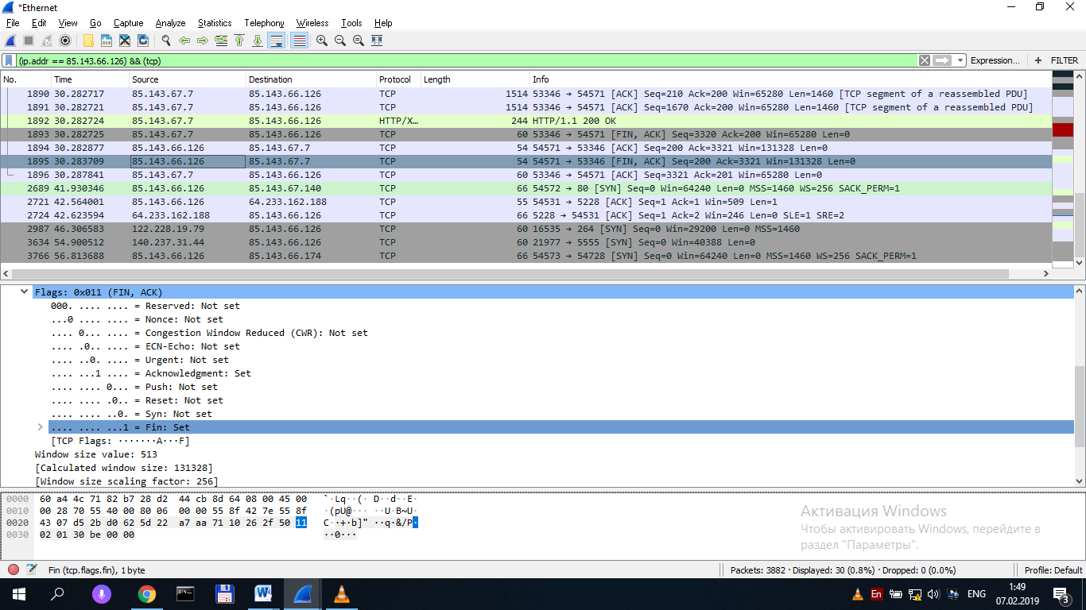
Figure 12 – FIN, ACK

Conclusion
In this lab, I learned how to use WireShark and VLC Player, and also learned how to analyze media transfer protocols for real-time options.

